TASK 2 - MOTOR CONTROL WITH PWM & OBSTACLE DETECTION
CODE :
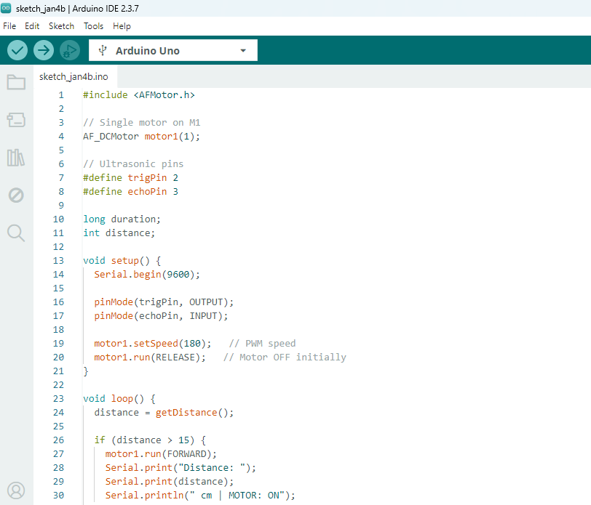
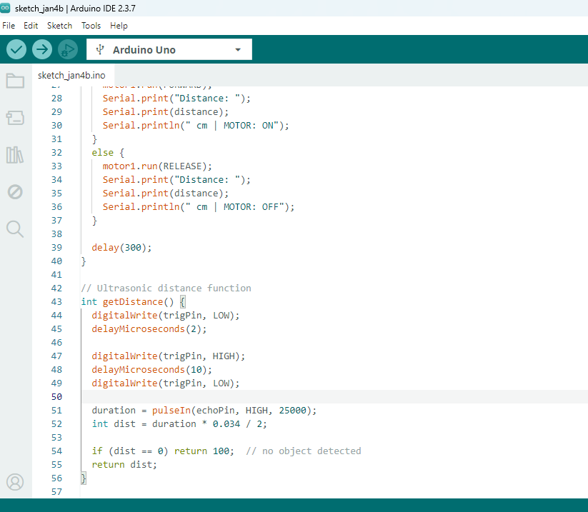

CODE OUTPUT :
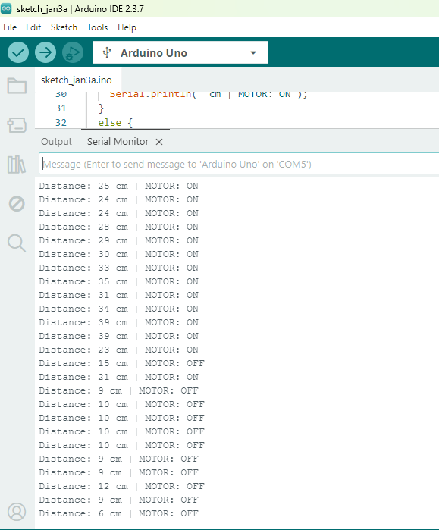
WIRING DIAGRAM :
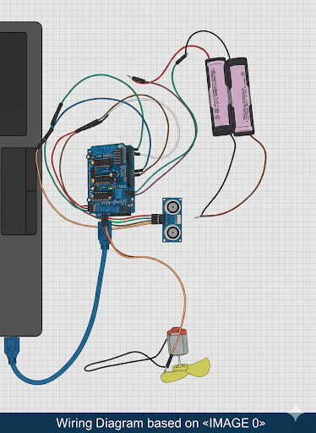
CIRCUIT :
